My God is So Big
Used by Permission. CCLI #11103902 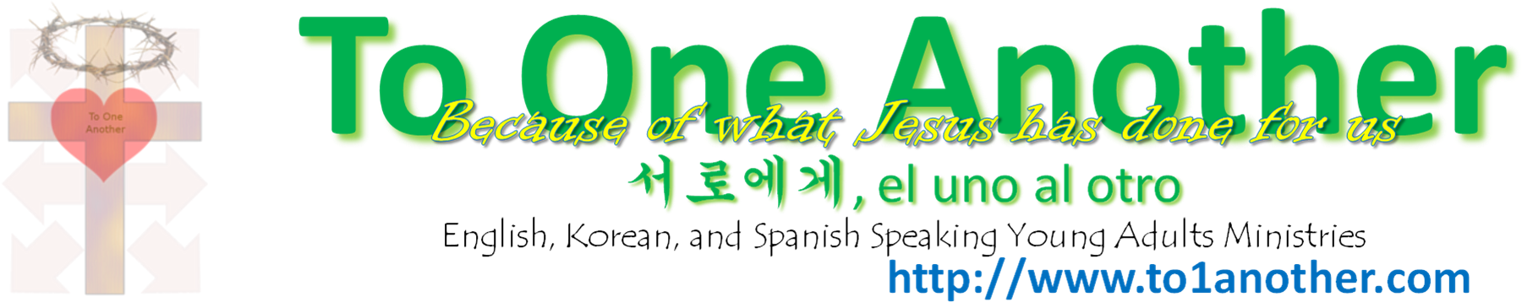
Used by Permission. CCLI #11103902

D (G)
My God is so big, so strong and so mighty
A (D) D (G)
There's nothing my God cannot do.
D (G)
My God is so big, so strong and so mighty
A (D) D (G)
There's nothing my God cannot do.

G (C)
The mountains are His,
D (G)
The valleys are His,
A (D) D (G)
The stars are His handiwork too.

D (G)
My God is so big, so strong and so mighty
A (D) D (G)
There's nothing my God cannot do.
Used by Permission. CCLI #11103902

